Clinical Feedback meeting notes by Goutam Reddy (greddy@abiogenix.com)

3/25/20 meeting @ Stanford Health

Interviewed: Dr. Linda Barman, Thanh Khong PAC (they run the drive-through swabbings)

Summary of Design Notes:

1. Most liked designs #15 > #13 > #11
2. Liked rounded tips
3. Liked wider necks
4. Liked USF design because it had a 100mm break-point with longer neck
5. Materials Comparison:

They liked PA11 the best because of the springback of the neck.

PA12G (gray) was too stiff and PA12W (white) was too weak.

Requested feel of a slightly stiffer PA11.

1. Want more elasticity from designs (spring-back). The nasopharynx has a kink ( "a little hill" and go down; want overall trajectory to be straight but go over the hill)

Swab Note:

The swab Stanford Health is using is Copan 503CS01, which has a 100mm breakpoint.

They both said our cut-off point was too short (again). See previous note for full measurements.

General Notes:

1. We should autoclave our swabs first to test material change prior to testing, and test at different temperatures.
2. For sterility, they suggested EtO as more commonly available than autoclave (globally).
3. Dr. Barman suggested a pre-bend/kink in neck of 5-10 degrees to assist with downward push.
4. Dr. Barman suggested making a spiral structure in neck to strengthen it
5. There are two techniques for swabbing:
   1. one is “twirling” - rotating the swab in the fingertips 5 times after insertion for 10 seconds
   2. the other is “swirling” (moving the hand with a circular motion)

Suggest we include training materials if there is a preferred way to use this swab.

1. drive-through patients: prefer to have patients look ahead or slightly turned so they can use the headrest for patient to push back against when expecting recoil of head from insertion of np swab

Test 11) Wyss Spiral in PA12 (mfg by Fathom in Oakland)

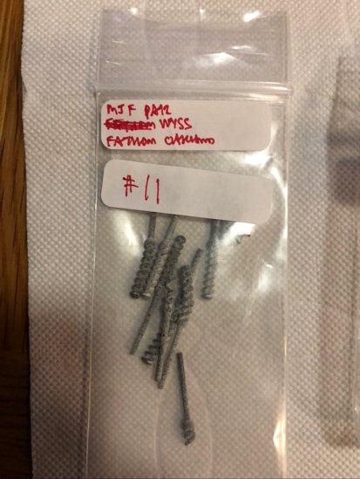

|  |  |  |  |  |  |  |
| --- | --- | --- | --- | --- | --- | --- |
| * like it; not bad; * as long as it doesn't break * too flexible: may jam in their nose * too brittle * you’re gonna get jammed up; make it less brittle and stiffer * breaks too easily |  |  | are you gonna get locked up; make it less brittle and stiffer |  |  | breaks too easily |

Test 12) USF PA11 (mfg by HP in San Diego)

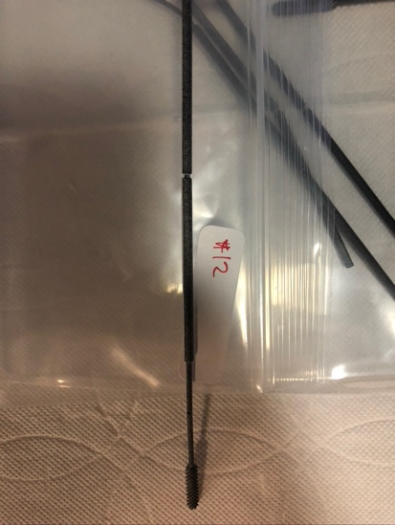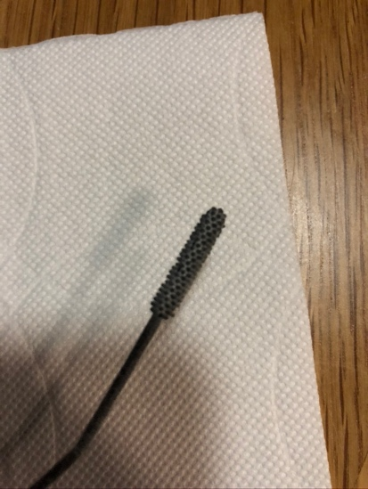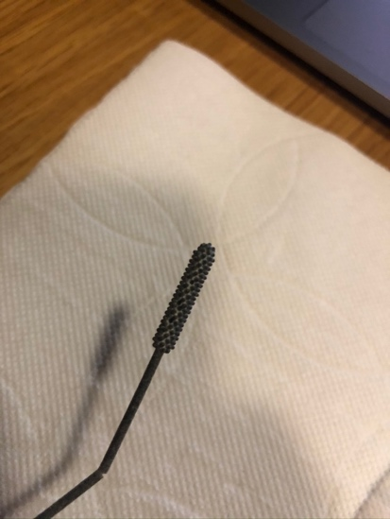

* liked burr tip
* note burrs do not come out in prints
* neck flexed and broke
* like that the breakpoint is moved up
* feels more like it won’t break in my hand
* feels harsh, too brittle, but like length
* check at different temperatures
* NOTE: burrs are inconsistent (too small features) for current MJF tech;
* worry burrs may fall/rub off in nasopharynx

Test 13) Fathom Squares Large (mfg by Fathom in Oakland)

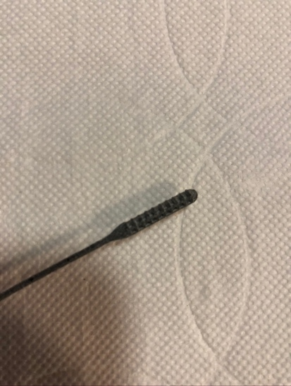

* really like rounded tips
* doesn’t feel bad; spring is good
* make neck longer (worried neck is thick too soon; that part goes in nares (neck) ; worried it won't go as deep; narrower and longer neck; like crevices
* check on structural integrity

Test 14) Fathom Squares Tiny (mfg by Fathom in Oakland)

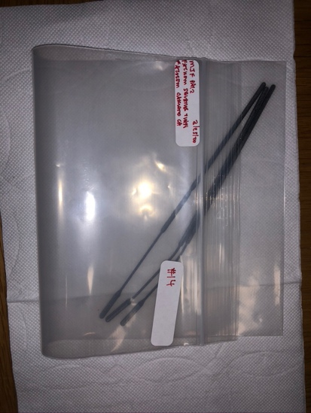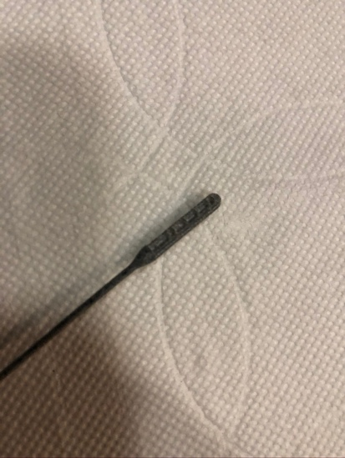

* check with fluid collection
* like roundness and roughness (not too rough)
* NOTE: features did not come out that well in this model

Test 15) Fathom-Branan Screw (mfg by Fathom in Oakland)

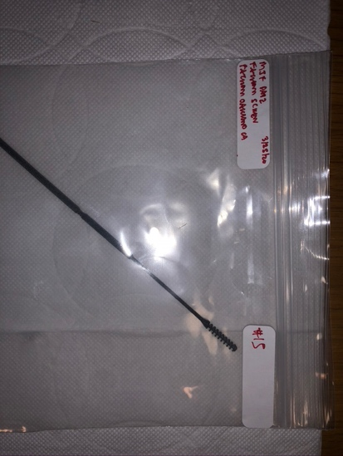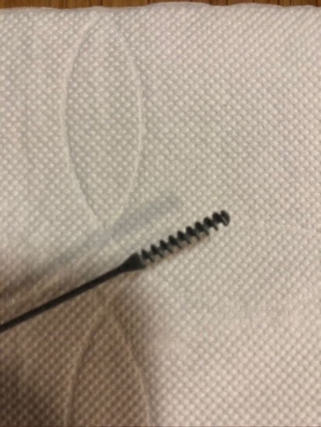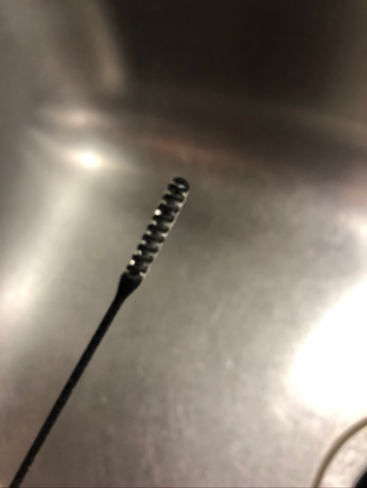

* do a torsional test
* great that it’s a little wider [than below designs]
* “my favorite”, “top choice”
* nice rounded top

Test 16, 17, 18, 19) HP Screw and Spring Designs Wide (mfg by HP Vancouver)

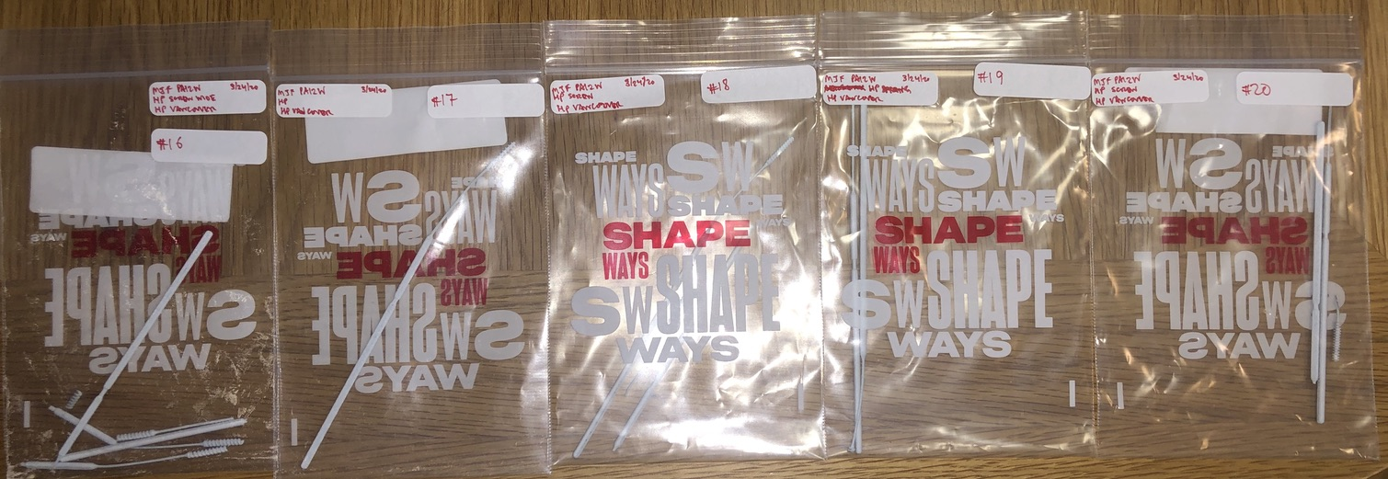

* too flexible
* won't be able to go through
* too pointy at end ; too pokey
* neck too brittle/ fragile => make thicker
* may not be wide enough
* too wimpy ; really breakables;
* not hard enough to guide
* head too small
* really didn’t like PA12W materials